Poirot Lucas
Midouni Samy
SAE R5A21 Compléments de probabilités et statistique
Tests d’hypothèse avec l’application R

Exercice 1
1)a) Le seuil x̄_{s} = 1.9009234
R = [1.9009234;+∞[
b) β(μ1) = 0.7691
c)
x̄_{s} | R | β(μ1) | π(μ1)
1.9009234 | [1.9009234;+∞[ | 0.7691 | 0.23208956

2) a)
x̄ = 1.88776
b)
x̄ ∉ R donc on ne peut pas rejeter H₀ au niveau 5%.
c)
Pc(x̄) = 0.052529
d)
Test non significatif car Pc(x̄) > 0.05
e)
On ne peut pas rejeter H0 au niveau 1 % car Pc(x̄) > 0.01
Exercice 2
1)a)
n | x̄_{s} | R | β(μ₁) | π(μ₁)
20 | 2.103401 | [ 2.103401 ;+∞[ | 0.750445 | 0.249555
30 | 1.9009234 | [1.9009234 ;+∞[ | 0.6765674 | 0.3234326
40 | 1.7802226 | [1.7802226;+∞[ | 0.6081626 | 0.3918374
50 | 1.6978523 | [1.6978523;+∞[ | 0.5449011 | 0.4550989
100 | 1.4934561 | [1.4934561 ;+∞[ | 0.3009003 | 0.6990997
150 | 1.4029052 | [1.4029052;+∞[ | 0.1565448 | 0.8434552
200 | 1.34892615 | [1.34892615;+∞[ | 0.07790932 | 0.92209068
250 | 1.31208903 | [1.31208903;+∞[ | 0.03746054 | 0.96253946
300 | 1.28489701 | [1.2848970;+∞[ | 0.01751882 | 0.98248118
350 | 1.263 763 | [1.263 763;+∞[ | 0,008 006 732 | 0,991 993 3

μ₁ = 1.65
σ = 3
b)
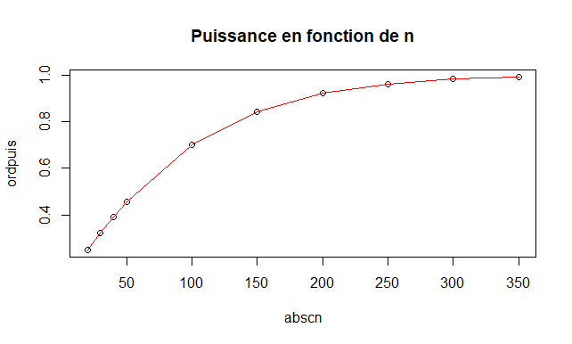

Quand on augmente n, la puissance tend vers 1.
2)a)

α | x̄_{s} | R | β(μ₁) | π(μ₁)
0.01 | 2.2741932 | [2.2741932;+∞[ | 0.8727768 | 0.1272232
0.02 | 2.1248846 | [2.1248846;+∞[ | 0.8070336 | 0.1929664
0.03 | 2.0301531 | [2.0301531;+∞[ | 0.7561781 | 0.2438219
0.04 | 1.9588903 | [1.9588903;+∞[ | 0.7136072 | 0.2863928
0.05 | 1.9009234 | [1.9009234;+∞[ | 0.6765674 | 0.3234326
0.06 | 1.8515846 | [1.8515846;+∞[ | 0.6435788 | 0.3564212
0.07 | 1.8083240 | [1.8083240;+∞[ | 0.6137318 | 0.3862682
0.08 | 1.7695894 | [1.7695894;+∞[ | 0.5864176 | 0.4135824
0.09 | 1.7343618 | [1.7343618;+∞[ | 0.5612041 | 0.4387959
0.10 | 1.7019347 | [1.7019347;+∞[ | 0.5377708 | 0.4622292
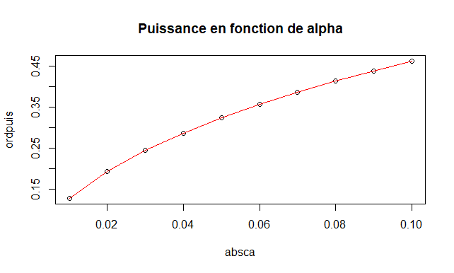
b)

Quand alpha augmente, la puissance augmente.

3) a)

μ₁ | x̄_{s} | R | β(μ₁) | π(μ₁)
1.5 | 1.9009234 | [1.9009234;+∞[ | 0.7679104 | 0.2320896
1.6 | 1.9009234 | [1.9009234;+∞[ | 0.7086374 | 0.2913626
1.7 | 1.9009234 | [1.9009234;+∞[ | 0.6431287 | 0.3568713
1.8 | 1.9009234 | [1.9009234;+∞[ | 0.5730953 | 0.4269047
1.9 | 1.9009234 | [1.9009234;+∞[ | 0.5006726 | 0.4993274
2.0 | 1.9009234 | [1.9009234;+∞[ | 0.4282277 | 0.5717723
2.1 | 1.9009234 | [1.9009234;+∞[ | 0.3581297 | 0.6418703
2.2 | 1.9009234 | [1.9009234;+∞[ | 0.2925204 | 0.7074796
2.3 | 1.9009234 | [1.9009234;+∞[ | 0.2331199 | 0.7668801
2.4 | 1.9009234 | [1.9009234;+∞[ | 0.181099 | 0.818901
2.5 | 1.9009234 | [1.9009234;+∞[ | 0.1370303 | 0.8629697

b)

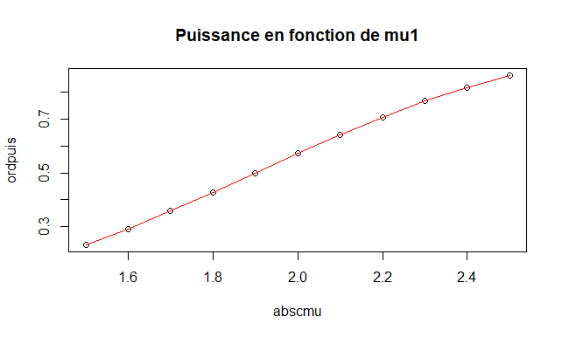

Quand μ₁ augmente, la puissance augmente

Exercice 3

1)
λ = 4.35

2)
Nombre d’appels x_{i} | 0 | 1 | 2 | 3 | 4 | 5
Nombre de minutes n_{i} observées | 4 | 18 | 33 | 49 | 41 | 33
Nombre théorique de minutes attendu th_{i} = nq_{i} | 3.0976350 | 13.4747123 | 29.3074993 | 42.4958740 | 46.2142630 | 40.2064088

Nombre d’appels x_{i} | 6 | 7 | 8 | 9 | 10 | 11 | 12
Nombre de minutes n_{i} observées | 19 | 16 | 8 | 6 | 6 | 4 | 3
Nombre théorique de minutes attendu th_{i} = nq_{i} | 29.1496464 | 18.1144231 | 9.8497176 | 4.7606968 | 2.0709031 | 0.8189481 | 0.2968687

3)

x_{i} | 0-1 | 2 | 3 | 4 | 5 | 6 | 7 | 8 | 9-10-11-12
n_{i} observés | 22 | 33 | 49 | 41 | 33 | 19 | 16 | 8 | 19
th_{i} = nq_{i} | 16.572 347 3 | 29.3074993 | 42.4958740 | 46.2142630 | 40.2064088 | 29.1496464 | 18.1144231 | 9.8497176 | 7.947 416 7

4)
d = 24.617

5)

ν=13-1-1-4 = 7

6)

δ = 14.06714

7) R = [14.06714;+∞[
8)
d ∈ R donc on peut rejeter H_{0.}
9)
Pc = 0.0008868198 < 0.001 donc le test est hautement significatif.

10 )
On rejette H₀ à 1% car Pc < 0.01.

